ComicCraft
AI Comic Story Creator using Google Gemini Models
Generative AI Project Documentation (8 Phases)
Contents
- 1. Brainstorming & Ideation Phase
- 2. Requirement Analysis Phase
- 3. Project Design Phase
- 4. Project Planning Phase
- 5. Project Development Phase
- 6. Project Testing Phase
- 7. Project Documentation Phase
- 8. Project Demonstration Phase

Phase 1: Brainstorming & Ideation

1.1 Problem Statement
Creating a comic requires storytelling, character design and illustration skills, which most people lack. Manual creation is slow, and non-artists have no easy way to turn a story idea into a finished comic.

1.2 Proposed Solution
ComicCraft is a web application that converts a short user prompt into a complete 5-panel comic. Google Gemini generates the story, narration and dialogue, and Gemini image generation produces the panel illustrations. The result is previewed in the browser and exported as a PDF.

1.3 Target Users
- Hobbyists and casual storytellers with no drawing skills
- Students and teachers creating visual stories for learning
- Content creators who need quick story concepts

1.4 Ideas Considered
Idea | Feasibility | Impact | Decision
Prompt-to-comic generator with PDF export | High | High | Selected
Story-only generator (text output) | High | Low | Rejected: less engaging
Multi-page comic with user accounts and library | Low (time) | High | Future scope
Manual comic editor with AI assistance | Medium | Medium | Future scope

1.5 Empathy Map
Says | Thinks | Feels | Does
"I have a story idea but cannot draw." | Comics are too hard to make. | Frustrated, limited creatively. | Searches for tools; gives up or hires artists.

1.6 Expected Impact
- Comic creation in minutes instead of days
- Consistent characters and coherent stories across panels
- Shareable, printable PDF output

Phase 2: Requirement Analysis

2.1 Functional Requirements
ID | Requirement
FR1 | Accept five inputs: story prompt, character name, setting, tone and art style.
FR2 | Generate a structured 5-panel story with description, narration and dialogue for each panel.
FR3 | Create one fixed character profile and reuse it in every panel for visual consistency.
FR4 | Generate one illustration per panel from the panel description and art style.
FR5 | Display all panels (image, narration, dialogue) as an on-screen preview.
FR6 | Export the comic as a PDF and provide a download link and success page.

2.2 Non-Functional Requirements
- Usability: Simple, responsive interface usable without technical knowledge.
- Reliability: Loading indicator and clear error message when generation fails.
- Security: API key stored in an environment variable, never hard-coded.
- Maintainability: Modular code (one file per responsibility) for easy extension.

2.3 User Stories
- As a user, I want to enter a story idea so that a full comic is created automatically.
- As a user, I want to pick the tone and art style so that the comic matches my vision.
- As a user, I want to download the comic as a PDF so that I can share or print it.

2.4 Software Requirements
Component | Requirement
Language / Framework | Python 3, FastAPI, Uvicorn, Jinja2, python-multipart
AI / Libraries | google-genai, pydantic, fpdf2, requests
Access | Gemini API key (GEMINI_API_KEY), internet connection, modern web browser

2.5 Constraints & Assumptions
- Each comic has exactly 5 panels; one comic is generated at a time.
- Requires an active internet connection and a valid Gemini API key with available quota.
- Users provide input in English; PDF text supports Latin characters only.

Phase 3: Project Design

3.1 System Architecture
Layer | Technology | Role
Frontend | HTML, CSS, JavaScript, Jinja2 | Collects input, shows loading state, renders panels and download button
Backend | FastAPI + Uvicorn | Routing, input handling, orchestration of AI calls, file output
Story AI | Gemini Flash model | Returns structured JSON: character profile and 5 panels
Image AI | Gemini Pro Image model | Generates a 1:1 illustration for each panel
Export | FPDF2 | Builds a multi-page PDF (one page per panel)

3.2 Data Flow
User form → POST /generate → Story generation (Gemini Flash) → Image prompt per panel → Image generation (Gemini Pro Image) → Layout builder → PDF export → JSON response → Preview and download in browser.

3.3 Model Selection
Task | Model (as configured) | Reason
Story, narration, dialogue | gemini-3.5-flash | Fast, supports schema-constrained JSON output
Panel illustrations | gemini-3-pro-image | High-quality images that follow detailed prompts

3.4 Module Design
File | Responsibility
main.py | Creates the app, mounts static files, serves / and /export-success
routes.py | POST /generate: runs the full generation pipeline
gemini_flash.py | generate_story(): builds the story prompt; validates output with Pydantic (Panel, ComicStory)
image_generator.py | generate_image(): requests a PNG image from Gemini and decodes it
layout_builder.py | build_layout(): pairs each panel’s text with its image path
exporters.py | save_pdf(): writes narration, dialogue and image to PDF pages
templates/ | index.html (form + live preview), comic_preview.html, export_success.html

3.5 Prompt Design
- Story prompt: fixed 5-part arc (introduce, develop, conflict, resolve, conclude) with continuity rules.
- Character profile: one visual description reused in every image prompt to keep the character consistent.
- Image prompt: art style + character profile + setting + scene; explicitly forbids text, speech bubbles and watermarks.

3.6 UI Flow
Home form → Loading message → Panel preview with PDF download → Export success page → “Create Another Comic”.

Phase 4: Project Planning

4.1 Milestones & Timeline
Milestone | Key Activities | Timeline
M1: Research & Setup | Select Gemini models; define architecture; set up Python environment and API key | 24 Sep 2026
M2: Core Modules | Story generation, layout builder and PDF exporter | 24–25 Sep 2026
M3: Backend Routes | FastAPI app, /generate route, image generation and error handling | 25–26 Sep 2026
M4: Frontend | Input form, loading state, preview page, export success page | 24–26 Sep 2026
M5: Testing & Deployment | End-to-end testing; local run script (run.sh) | 26–28 Sep 2026

4.2 Roles
Role | Responsibility
AI / Backend Developer | Prompts, Gemini integration, FastAPI routes
Frontend Developer | HTML/CSS/JS interface and templates
Tester / Documentation | Test cases, bug tracking, project report

Note: assign team member names to each role before submission.

4.3 Risks & Mitigation
Risk | Mitigation
API quota or key errors | Check key at start; return clear error; keep key in .env
Inconsistent character appearance | Single fixed character profile reused in every image prompt
Slow generation (5 sequential image calls) | Loading indicator; future: parallel image requests
Malformed model output | Schema-constrained JSON validated with Pydantic

4.4 Tools
Python 3, VS Code / Termux, Git, Uvicorn, FastAPI /docs (Swagger), Google AI Studio (API key).

Phase 5: Project Development

5.1 Environment Setup
python -m venv comiccraft-env
source comiccraft-env/bin/activate # Windows: comiccraft-env\Scripts\activate
pip install -r requirements.txt
# .env file: GEMINI_API_KEY=<your-api-key>

5.2 Project Structure
ComicCraft/
main.py routes.py gemini_flash.py image_generator.py
layout_builder.py exporters.py requirements.txt run.sh
templates/ index.html comic_preview.html export_success.html
static/generated/ (panel images and comic.pdf)

5.3 Implementation Summary
Step | Implementation
1. Input | /generate reads prompt, character, setting, tone and style using FastAPI Form(...)
2. Story | generate_story() calls Gemini Flash once and validates the JSON against the ComicStory schema
3. Images | For each panel, a detailed image prompt is built and generate_image() saves panel_N.png
4. Layout | build_layout() combines panel text and image path
5. PDF | save_pdf() creates comic.pdf; non-Latin characters are replaced to avoid encoding errors
6. Response | JSON with panels and PDF path; JavaScript renders the preview with HTML-escaped text

5.4 Run the Application
uvicorn main:app --host 0.0.0.0 --port 8000 # or: bash run.sh
Open http://127.0.0.1:8000 for the app and /docs for API testing.

Phase 6: Project Testing

6.1 Test Cases
ID | Test Case | Expected Result | Status
TC1 | Submit valid inputs (Rabbit vs Tortoise race story) | 5 panels, 5 images and comic.pdf are created | Pass (sample output available)
TC2 | Submit with an empty field | Form validation blocks submission | To be run
TC3 | Remove GEMINI_API_KEY | Clear "key is missing" error | To be run
TC4 | Choose “Funny” tone with “Anime” style | Story and images reflect chosen tone and style | To be run
TC5 | Character appearance across panels | Same character in all 5 panels | Pass (sample output reviewed)
TC6 | Click Download PDF / Export | PDF downloads; success page opens | To be run
TC7 | API failure or timeout | User sees "Comic generation failed." | To be run

6.2 Output Quality Evaluation
Criterion | What is checked
Story coherence | Five connected panels with a clear beginning, conflict and ending
Prompt adherence | Scene matches the description, setting and art style
Character consistency | Face, clothing and proportions remain constant
Text-free images | No stray text, speech bubbles or watermarks in images
Safety | Generated content is appropriate for the chosen tone

6.3 Known Issues
- Output files (panel_N.png, comic.pdf) are overwritten by each new comic; concurrent users would conflict.
- Images are generated one by one, so total time grows with panel count.
- No automatic retry when the Gemini API fails or is rate-limited.
Record the actual result and date for every test case marked “To be run” before final submission.

Phase 7: Project Documentation

7.1 User Guide
- Step 1: Open the ComicCraft home page.
- Step 2: Enter story idea, character name, setting, tone and art style.
- Step 3: Click Generate and wait for the loading message to finish.
- Step 4: Review the panels, then click Download PDF.
- Step 5: Choose “Create Another Comic” to start again.

7.2 API Reference
Method | Endpoint | Purpose
GET | / | Home page with input form
POST | /generate | Generate comic from form fields; returns panels and PDF path as JSON
GET | /export-success | Export confirmation page with PDF download link
GET | /docs | Interactive Swagger API documentation

7.3 Setup & Security Notes
- Set GEMINI_API_KEY in a .env file; do not share or commit this file.
- Install dependencies with pip install -r requirements.txt.
- run.sh is written for Termux (Android); use the uvicorn command on other systems.

7.4 Limitations
- Fixed at 5 panels; single-user, no login or saved comic library.
- PDF supports Latin characters only; depends on an internet connection and API quota.

7.5 Future Scope
- User accounts and a personal comic library
- Selectable panel count and multi-page story arcs
- Speech bubbles drawn on images and in-app panel editing or regeneration
- Parallel image generation and unique file names per user session

Phase 8: Project Demonstration

8.1 Demo Script (5 minutes)
Step | Action | Talking Point
1 | Introduce the problem | Non-artists cannot easily turn ideas into comics
2 | Show home page and enter inputs | Five simple inputs drive the whole comic
3 | Click Generate | Gemini Flash writes the story; Gemini Pro Image draws each panel
4 | Show the preview | Five panels with narration and dialogue; same character throughout
5 | Download PDF and open success page | Print-ready output in one click
6 | Open /docs | API is documented and testable

8.2 Sample Outcome
Story prompt: “The Rabbit and the Tortoise race.” Output: 5-panel comic with narration, dialogue and PDF.
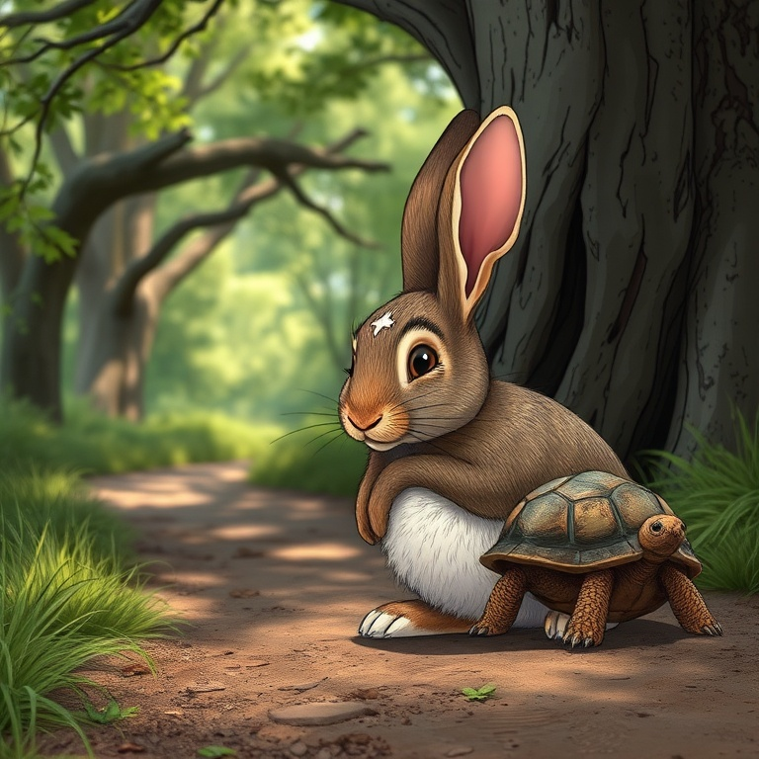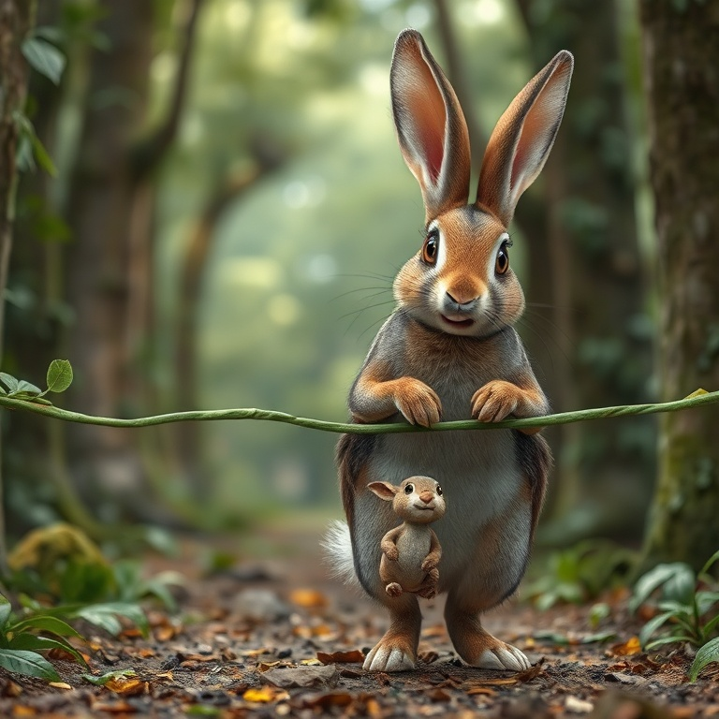
Panels 1, 3 and 5 of the generated comic

8.3 Key Outcomes
- End-to-end pipeline: prompt → story → images → preview → PDF
- Structured, validated AI output using a Pydantic schema
- Consistent character across panels using a fixed character profile

8.4 Presentation Outline
1. Problem 2. Solution 3. Architecture 4. Live demo 5. Results 6. Limitations 7. Future scope 8. Q&A

8.5 Likely Questions
Question | Answer
How is character consistency achieved? | One fixed character profile is generated and included in every image prompt.
How is the AI output kept structured? | The story model returns JSON following a Pydantic schema, which is validated.
Why two Gemini models? | A fast model for structured story text; an image model for illustrations.
What are the main limitations? | Fixed 5 panels, sequential generation, files overwritten per request.

